Model Exercise 3: Calibration and Uncertainty

Consider the model developed in Exercise 2:
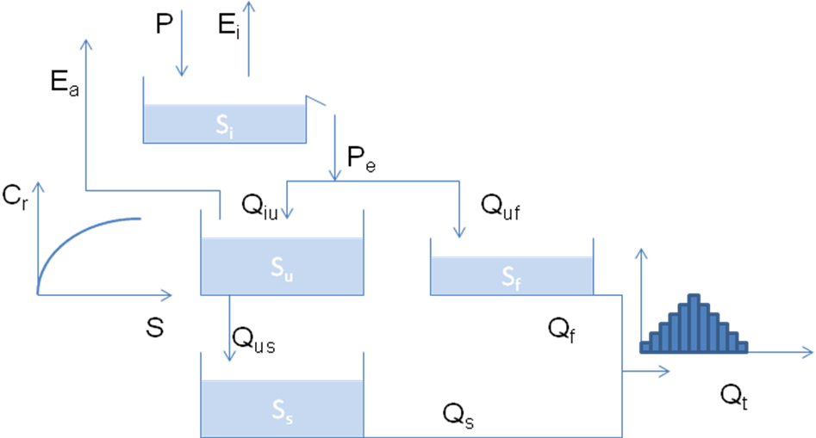

- Write the model in this form N=m(θ), where N is the Nash and Sutcliffe coefficient, m is the model, and θ is the model parameter vector.
- Put the model in a Monte Carlo loop, calculate N for each θ and discard the parameter sets that correspond to a performance that is below a specified threshold (e.g. N=0.6)
- Determine the optimum parameter set
- Analyze parameter uncertainty
- Repeat the analysis using as objective the Nash of the log of the flows.
- Below are the figures that you should be able to reproduce

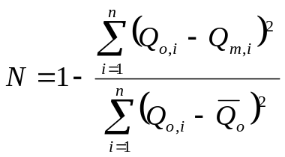
Where Q is discharge, the subscripts o and m stand for observed and modeled respectively, i is the time step, and the overbar indicates an average.
